1. BSheba.com :

It has four steps to get service,

* Select Your Area
* Choose Service Type
* Select your nearest Provider
* Fixed Date & Time

Dashboard:

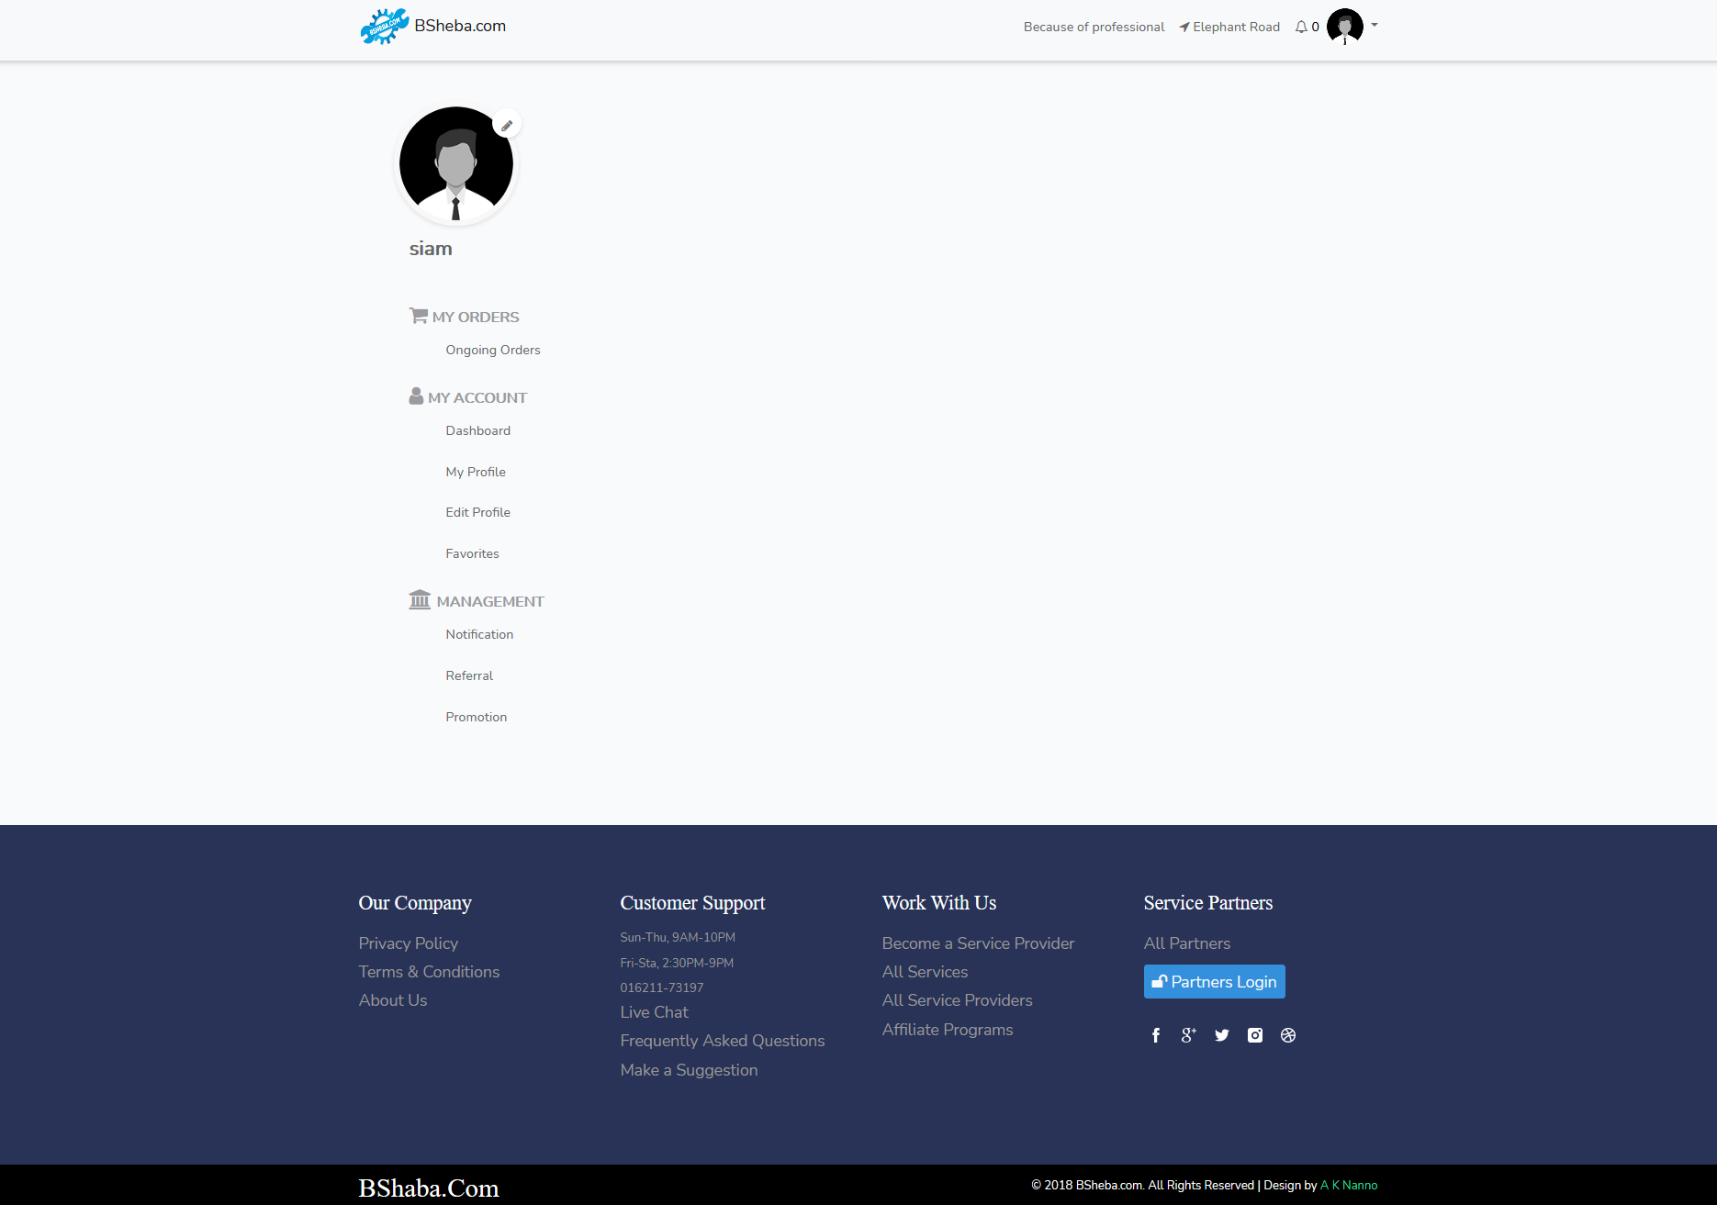

Order process:

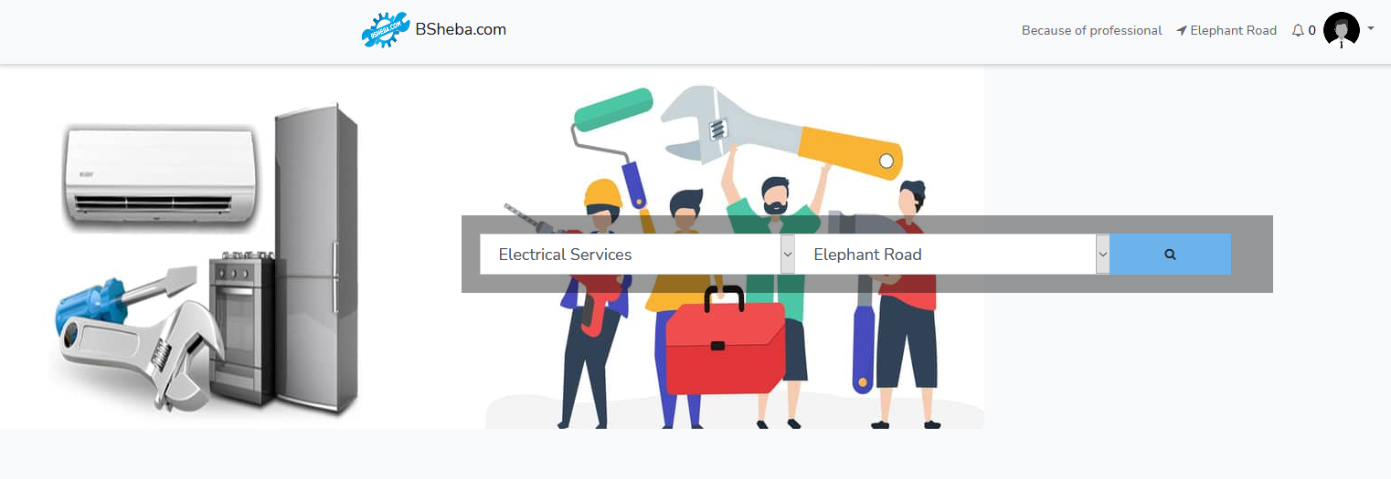

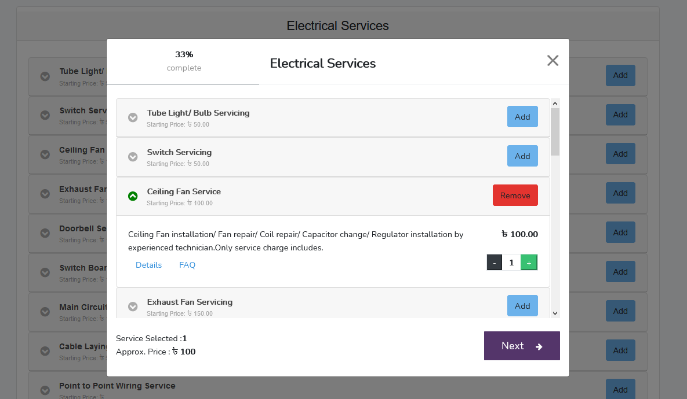

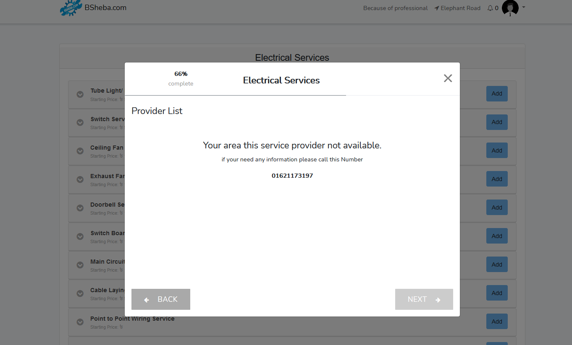



Website: <https://www.bsheba.com/>

1. Mistrimama:

Features:

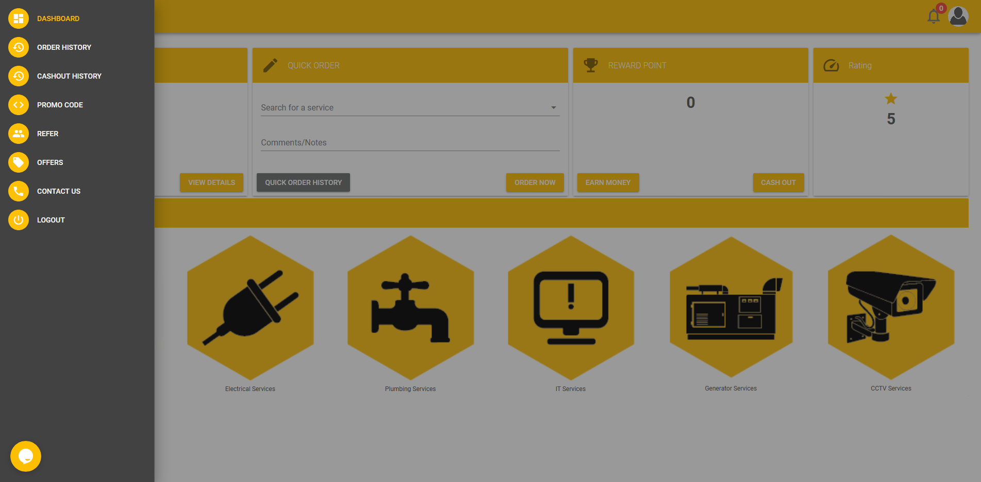

Order System:

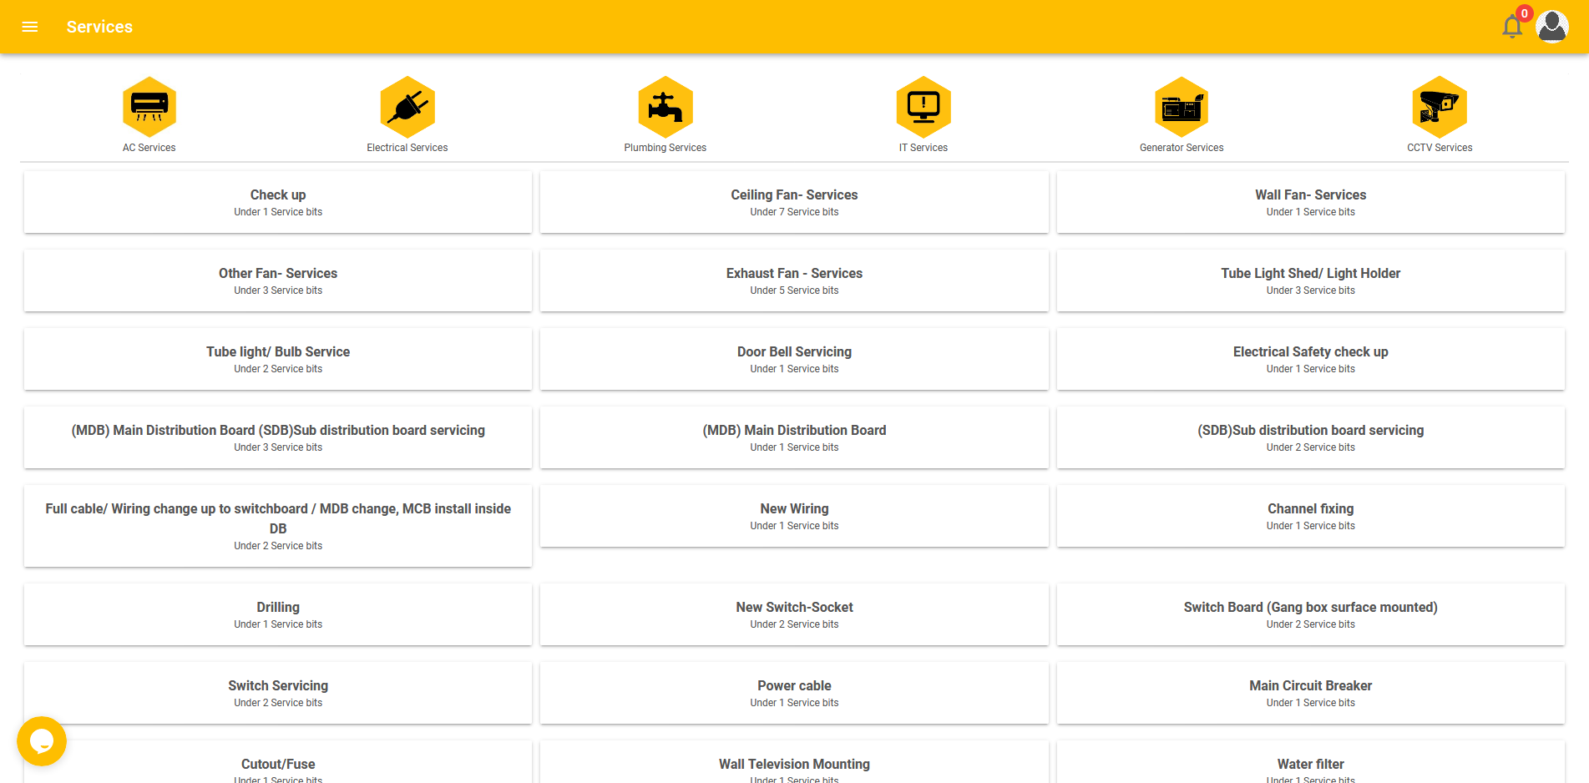

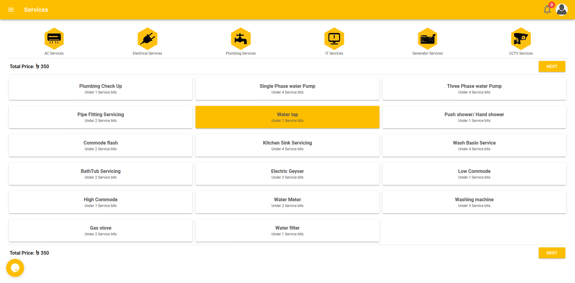

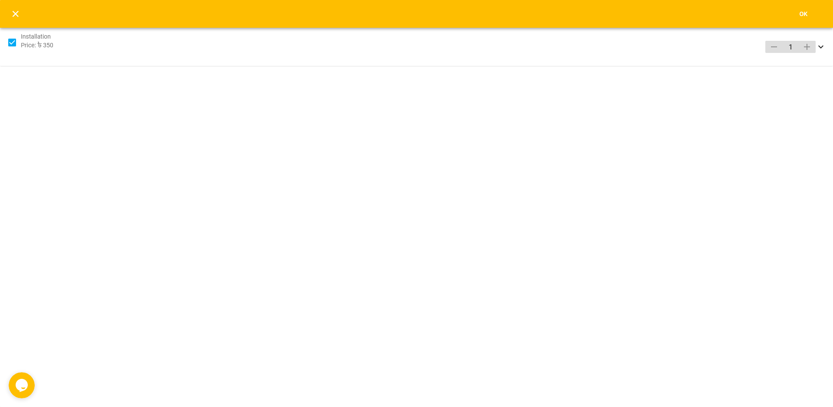

----------------------------------------------------------------------------------------------------

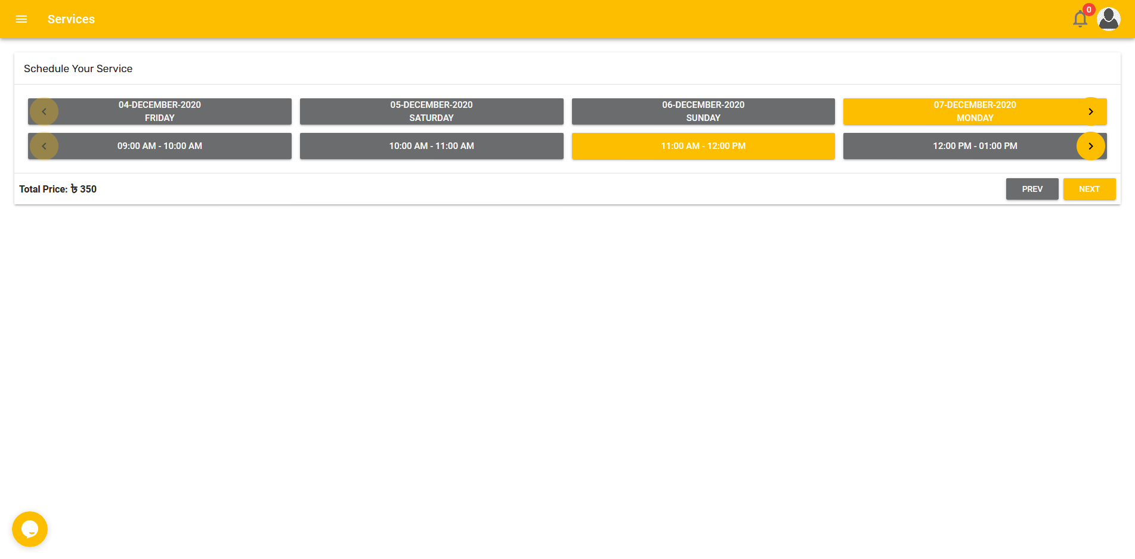

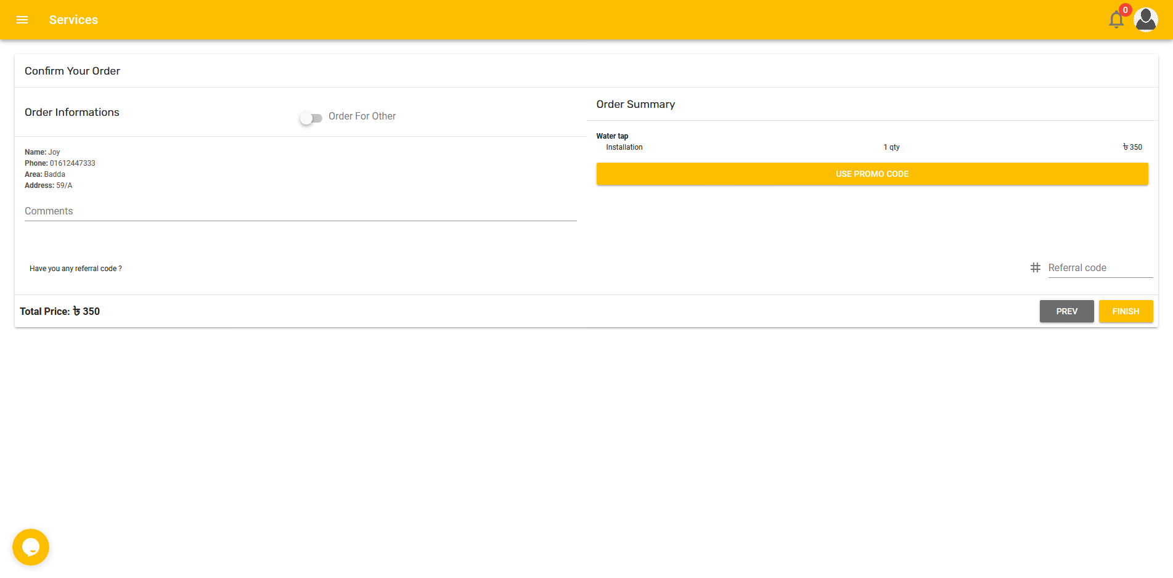

## About Mistri Mama

Mistri Mama is an online-based service platform that offers home services in all areas of Dhaka City. We ensure quality service by providing training to our technicians which also emphasis safety and behavioral aspects. Apart from the domiciliary service, we also provide a one-time, periodical subscription for corporate houses. Our highly trained and professional technicians are always a CALL away to provide Electrical Services, Plumbing Services, Air Conditioner Services, CCTV Services, IT Services, Generator Services. servicing works at your doorstep. Contact us to request a service through our Mistri Mama webpage, over the phone or social media pages. We are also open to provide our services during holidays/emergency hours / your free hours

Mistri Mama is a sister concern of SSG (Super Star Group), a renowned electrical & electronics conglomerate in Bangladesh, was founded on the principles of harmony, sincerity and pioneering spirit for more than two decades. SSG brand has become synonymous with lifestyle and household electrical products from lighting solutions to electrical accessories, fans to engineering products, properties to renewable energy. The group and its subsidiaries, have had a significant impact on society shaping the future for the 21st century and beyond. The strive for brighter future SSG introduces Mistri Mama.

## Purpose of Our Service

Technician is a common word in the service industry. But when it comes to an experienced service technician, it is really hard to find. There is no measurement policy to rate them, until you receive the service, experience them. Also, there is a huge question in security measures or the trustworthiness of unknown technicians. Should you let them in your perfect house, or not? To ease up this huge responsibility from your back to find a suitable and experienced service technician, we are here. Mistri Mama is just one call away to make your troubled living perfect.

## Our Objective

“Providing quality services with the best customer experience through developing and empowering the local skilled workforce.”

All too often, consumers are forced to deal with appliance repair companies who send rude, inconsiderate, and just plain messy technicians to their homes. But not with Mistri Mama. We know just how awful of an experience that is, and we are committed to being different. That is why you can be confident knowing that when you hire our team, you will be working with technicians who are experts, trustworthy but also who are polite and respectful. Not only do they respect you and your time, but they also respect your home. All of our technicians abide by our commitment to leave no trace behind. In fact, it is our goal to always leave your home in better shape than it was when we arrived. Other than your fixed appliances, you shouldn’t even notice we were there at all!

## What Do We Do

We are providing quality services with the best customer experience through developing and empowering the local skilled workforce. Currently, we are offering a variety of services udder six (6) major services. They are;

* Air Conditioner Services
* Electrical Services
* Plumbing Services
* IT Services
* CCTV Services
* Generator Services

When a service is required, the user can visit the Mistri Mama website, call us on call center number or knock us on social media pages to get the service. Mistri Mama respect your time more than anything. In fact, we promise we will always show up on time for your scheduled appointment and that we will deliver service that is fast, efficient, and detail-oriented. To take it a step further, the experts who arrive at your door will be wearing clean attire and will have an ID badge on them.

## Why Choose Us

Why else should you work with Mistri Mama technicians instead of regular technicians? Because we care. We care about your time, your privacy, your appliances. Mistri Mama knows how much you rely on those machines every day to keep your home in working order, and we are committed to helping you get your house running smoothly again. However, we also know that who you hire to come to fix your appliances is equally important. That is why we are so proud to have expert technicians on our team. We provide fast, efficient services that pay attention to the details and get your appliances to prime condition.

We provide our services at your desired time. Which means any convenient time that the user demands. Holiday, late-night, even on emergency hours. Our service partners are committed to providing the service at your selected hour. With these services, we offer accurate and valid service charges to our customers. Individual service charges and service detail is given on the website, which clears out all the confusion of what you will get at what price. It reduces all the hustle of price negotiations.

Website: <https://www.mistrimama.com/>

1. <https://shomadhan.com/>

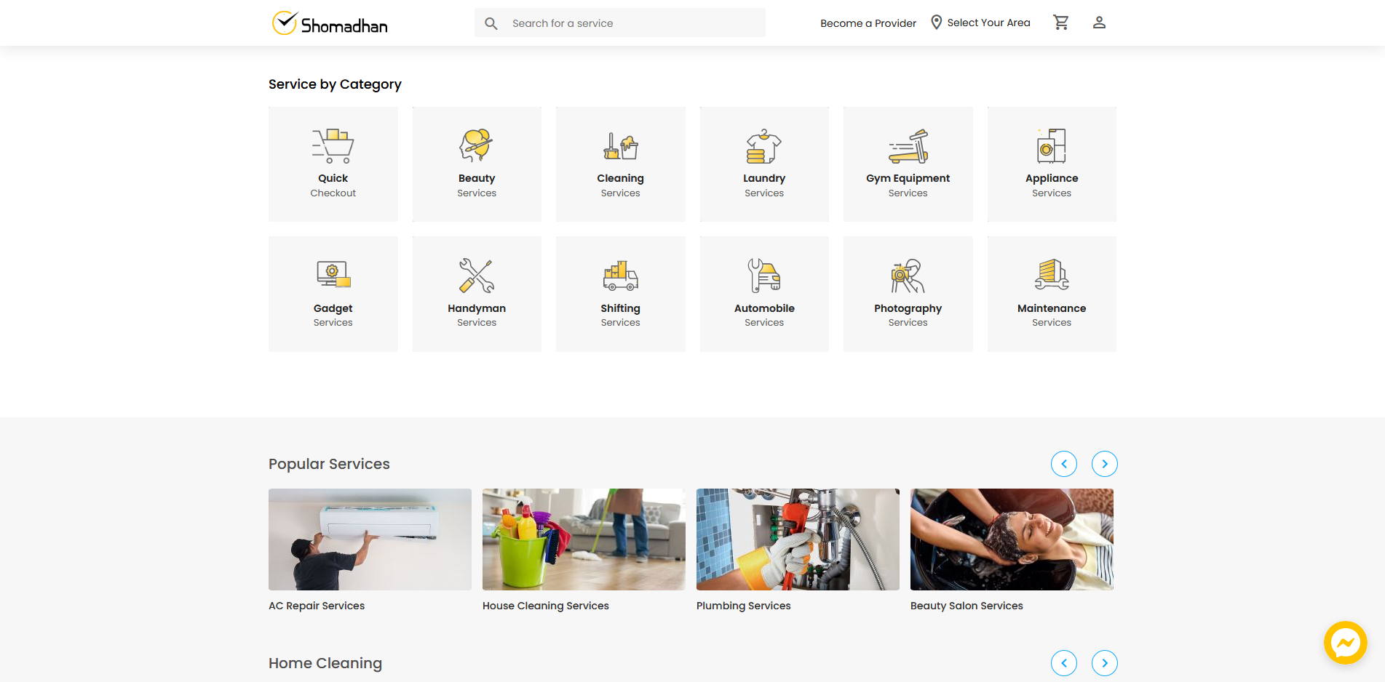

1. <https://cityumbrella.biz/>
2. <https://www.bdelectrician.com/electrical-services.html>
3. <https://www.sheba.xyz/>
4. <http://handymama.co/signin>

**About HandyMama**

HandyMama is on-demand cleaning service platform in Bangladesh. We connect our users with verified professional cleaners. You can book hourly, one-off clean or schedule a regular cleaning for your home and office. We launched pilot in mid 2015, ran beta till mid 2016. So far we have trained and created jobs for over 2,000 professionals, who have served over 70,000 households and 5000 businesses. Our vision is to train, certify and employ 10,000 people by next 5 years. We are a team of 35 passionate full-time people, including 10 brilliant software engineers. We are building a technology that is scalable in international market.

## Online Booking

Book any service instantly using a secure mobile app and website. Track your booking with real time data feed and tasker location. Rate your tasker and give feedback.

## Easy & Secured

Getting things done with HandyMama is easy. Besides, your data is secured in our cloud system, powered by latest technologies and security tools.

## Verified & Insured Pro

All HandyMama registered service professionals are thoroughly verified, 4-steps trained and covered safety and health insurance.

## Fastest Job Delivery

Don’t wait days, weeks. You book a service with HandyMama, you get it done in hours.

## Service Warranty

All the services are covered under 7 days service warranty. No questions asked.

## Satisfaction Guaranteed

If you are not happy with our service, we do it again and again until you smile.

1. <https://www.foodpanda.com.bd/restaurant/f5db/bowls>
2. <http://www.shower-services.co.uk/#about>
3. <https://www.triplemelectrical.co.uk/>
4. <https://greenflame.london/electric-service-london/>
5. <https://www.calllovenow.com/about-us/>
6. <https://www.artplumbingandac.com/plumbing/emergency-plumbing-services/>